Pollination biology of Hawk moths (Sphingidae) proved their potential role as pollinators of Angiosperms found in Himalayan ecosystem of North-East India

Navneet Singh1, 3, *, Dipayan Mitra1, 4, Rajesh Lenka1, 5, Pallab Chatterjee1, 6, Sadhan Kumar

Basumatary2, 7 & Swati Tripathi2, 8

1Zoological Survey of India, M Block, New Alipore, Kolkata-700053

2Birbal Sahni Institute of Palaeosciences, Quaternary Palynology Laboratory, 53, University Road, Lucknow-226007, Uttar Pradesh

3email ID: [nsgill007@gmail.com](mailto:nsgill007@gmail.com), ORCID:

4email ID: [dip.the.nocturnal@gmail.com](mailto:dip.the.nocturnal@gmail.com), ORCID:

5email ID: [untamedwild85@gmail.com](mailto:untamedwild85@gmail.com), ORCID:

6email ID: [cpallab06@gmail.com](mailto:cpallab06@gmail.com), ORCID:

7email ID:

8email ID:

# Keywords

Sphingidae, sphingophily, moth-pollination, pollen transportation, potential pollinator

# Abstract

This study presents a palynological analysis on the different Sphingidae moth species and pollen adherence in relation to the pollination and current vegetation and climate in the Himalayan ecosystem of North-East India. The study reveals that the 29 moth species under Sphingidae family are directly depend on the local and regional vegetation as evidenced with the presence of adherence pollen with their proboscides. The overall pollen assemblage recovered from the studied moth species are indicative of the subtropical evergreen and broad-leaved forest composing of *Elaeocarpus*, *Quercus*, *Betula*, Oleaceae, and *Rhododendron* under warm and humid condition which exactly reflected the current vegetation scenario in the region. The recovery of evergreen pollen taxa along with *Impatiens* inSphingidae moth samples was marked and indicative of the high rainfall activity in the region. However, the recovery of cereal and *Brassica* pollen in some moth sample strongly indicative of the anthropogenic activities in and around the study areas. This recorded data will be useful to understand the pollination biology of the different Sphingidae moth species in relation to the current vegetation and climate in the region.

# Introduction

Pollination is the most basic and exclusive process to maintain biodiversity. In order Lepidoptera, the moths (nocturnal) perform a significant role in this basic physical process. Co-evolution theory of Darwin support that long spurred flowers are primarily visited by long tongued hawk moths than other hovering moths (Haber & Frankie, 1989). Among the nocturnal insects, hawk moths show their polyphagous and cross pollinating nature because they collect nectar of long spurred flowers with their long distance movement which ultimately results in gene flow between fragmented plant populations. (Kritsky, 1991; Martins & Johnson, 2013; Willmott & Burquez, 1996; Miller, 1981, 1985, 1997; Goyret, Markwell &Raguso, 2007; Riffell *et al*., 2008). It was suggested that they can directly use their long tongue to pollinate long corolla flowers (Tuttle, 2007; Young et al., 2017). Broad scale geographically distributed hawk moths are phylogenetically more conserved and shows different temporal activity depending on their tongue length (de Camargo et al., 2016). Apart from morphological characters, presence and absence of some chemical compounds enhance hawk moth and long spurred flower interactions (Fox et al., 2013). A huge number of flora are reported to be pollinated by several hawk moths worldwide (Grant, 1983). Apart from them, various angiosperm taxa of different habitat like herb, shrub, trees and epiphytes also interact with hawks throughout the world (Haber & Frankie, 1989). Some important plant taxa like Orchidaceae and Caryophyllaceae in Europe and North-America; Fabaceae, Amaryllidaceae, Solanaceae, Orobanchaceae, Iridaceae, Apocynaceae, Meliaceae, Rubiaceae, Oleaceae, Malvaceae (Baobab) in Latin America and Africa were reported to be interacted by these hawk moths (Nilsson et al., 1992; Manning & Snijman, 2002; Alexandersson & Johnson, 2002; Peter et al., 2009; (O et al., 2011) (Ryckewaert et al., 2011); Martins & Johnson, 2013; (Martins & Johnson, 2013) Fox et al., 2013b, 2015; Hahn & Brühl, 2016). At larval stage hawk moths interacts with Convolvulaceae, Rubiaceae, Balsaminaceae and Vitaceae (Willmott & Búrquez, 1996) Johnson & Raguso, 2016).

But studying these moths in order to know their role in pollination is somewhat difficult due to these two basic characters i.e. (i) nocturnal habit and (ii) swift flight (Sheviak & Bowles, 1986) but pollen grains found on different body parts, proboscides of these nocturnal moths were examined in various studies to see their role as pollinators or pollen transporters ((Atwater & Lott, 2011; Banza et al., 2015). The amount of pollen grains carried by a moth can be termed as “carrying capacity”. If the carrying capacity of moth is found to be five or more than five pollen grain of a particular plant species then that moth can be termed as potential pollinator of that plant species(Macgregor et al., 2015). Apart from this, nocturnal pollen transfer network construction and the calculation of several network level matrices also provides important insights regarding their significant role as pollinators as same as that to the diurnal pollinators (Macgregor et al., 2015; R. E. Walton et al., 2020; R. Walton et al., 2021). All these methods were found to be beneficial and also act as strong evidences for exhibiting their role as pollen drivers.

According to the floristic compositions of North-East India has been divided in two major biogeographic zones i.e. North-Eastern Himalaya and Eastern Himalaya (Chakravarty et al., 2012). Three states viz. Sikkim, Arunachal Pradesh and West Bengal mostly represent the Himalayan ecosystem of North-East India. Among the recorded plant species, Sikkim, Bhutan and part of West Bengal (6283) has more plant species than Arunachal Pradesh (4503). This lower number of plant species in Arunachal Pradesh is due to under exploration (Rana & Rawat, 2017). Studies on pollination of three Himalayan species of *Roscoea* of family Lamiaceae (*R. auriculata, R.capitate, R.tumjensis*) have been conducted in central Himalayan ecosystem (Paudel et al., 2019). On the other hand, 184 species of hawk moths under 3 subfamilies were recorded in North-East India, where Sphingidae subfamily is the richest among all (Chandra et al., 2018).

As the ecosystem of these region depends largely on pollination, we represent a unique study on hawk moth pollination based on previous works and two other parameters i.e., carrying of pollens belonging to one or more than one angiosperm taxa and migration of hawk moth subfamilies along altitudes with special emphasize on subfamily Macroglossinae. This study reveals abroad hawk moth-plant interaction on the basis of Palynoassemblages and pollen structures. However, this is the first time the pollen adhering on the moth proboscis and other body parts along with the palynological analysis of the adhered pollens was conducted to understand the vegetation types in relation to the current vegetation, climate and land use forms in and around the study regions.

# Methodology

## Sampling sites and distribution of plant and moth taxa

Two districts of Sikkim (South Sikkim and East Sikkim), three districts of West Bengal (Alipurduar, Kalimpong and Jalpaiguri) and one district of Arunachal Pradesh (West Kameng) were surveyed from June, 2018 to July, 2020. Survey areas of northern part of West Bengal and Sikkim and Arunachal Pradesh mainly covers Sub-Tropical evergreen to agricultural landscapes. Some important taxa of Sikkim are *Ficus, Rhododendron, Acer, and Elaeocarpus;* of Arunachal Pradesh are *Dipterocarpus, Terminalia, Lagerstroemia, Morus, Gmelina, Oroxylum, Phyllanthus, Xanthium, Azadirachta indica, Caryota urens, Cassia fistula, Alnus nepalensis* and *Albizia lebbeck.* On the other hand, according to the altitudinal gradient richness of Macroglossinae is more than other two subfamilies (Sublett et al., 2019). The details of the study localities, climatic conditions of each locality were given in Table 1, Figure 1.

|  |  |  |  |  |  |  |  |  |
| --- | --- | --- | --- | --- | --- | --- | --- | --- |
| Id | Name | Lat | Long | Temp (ºC) | Humidity (%) | ppt (cm) | Pressure (hPa) | Moon phase (%) |
| 1 | Sitong | 26.9378 | 88.3714 | 20 | NA | 1.6 | 723 | 84.1 |
| 2 | Eche gaon | 27.1336 | 88.5744 | 26 | NA | 0.6 | NA | 56.1 |
| 3 | Jhendi | 27.0189 | 88.6472 | 18 | NA | 1.1 | 1004 | 42.7 |
| 4 | Lataguri | 26.7475 | 88.7653 | 12 | 96 | 2.1 | 810 | 63.3 |
| 5 | Rishop | 27.1086 | 88.6486 | 16 | 91 | 0.8 | NA | 49.1 |
| 6 | Jayanti | 26.7039 | 88.6094 | 14 | 93 | 1.2 | 911 | 91.6 |
| 7 | Panthyang | 27.3639 | 88.5686 | 21 | 44 | 0 | NA | 2.5 |
| 8 | Dikchu | 27.3990 | 88.5233 | 25 | 70 | 0.8 | 890 | 9.6 |
| 9 | Bermiak | 27.2532 | 88.2332 | 19 | 60 | 0 | 1004 | 98.7 |
| 10 | Ravangla | 27.2857 | 88.3541 | 17 | 81 | 0.2 | 1006 | 85.2 |
| 11 | Tenga Valley | 27.2128 | 92.4642 | 12 | 95 | 1.5 | 1007 | 23.91 |
| 12 | Salari | 27.3075 | 92.4096 | 12 | 96 | 0.8 | 819 | 34.93 |
| 13 | Shergaon | 27.1342 | 92.2739 | 9 | 94 | 0.6 | 809 | 44.79 |
| 14 | Eaglenest WLS | 27.1575 | 92.4608 | 7 | 81 | 0 | NA | 66.43 |

**Table 1.** Details of the study localities in three North-Eastern states of India

Note: Abbreviations used– ºC (degree celsius), ppt (Precipitation), cm (centimetre), hPa (hectoPascals), WLS (Wildlife Sanctuary).

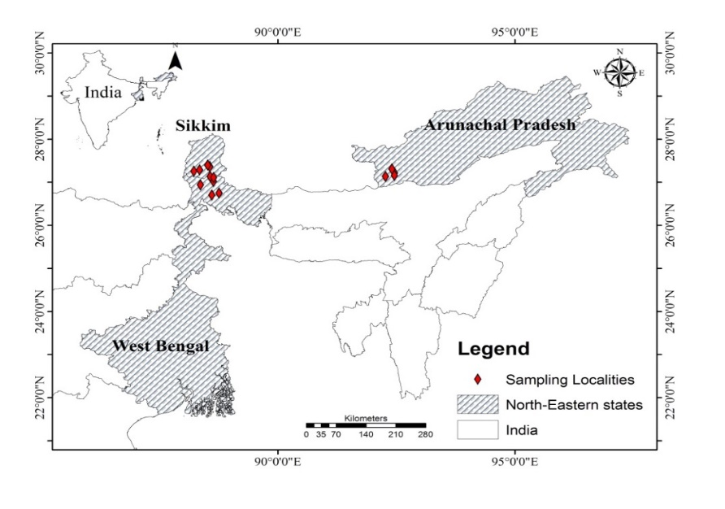**Figure 1.** Map showing locations of the studied areas

Hawk moths are mainly distributed in higher altitudes rather than lower altitudes. Subfamily Macroglossinae in Arunachal Pradesh is distributed from tropical region to alpine region. In state of Sikkim and part of North Bengal shows same diversity like Arunachal Pradesh.

## Field work

### Collection of Moths and isolation of proboscis

### Moth specimens were collected from vertical sheet light trap using mercury vapor lamp (125 wt) stationed at different altitudinal gradients in above-mentioned sampling localities. Moths were killed using Ethyl acetate in individual small containers to eliminate the pollen contaminations. Then proboscis of each moth was isolated and kept in vials with code number. After that the moths were kept in individual envelop with proboscis code number. Later moths have been kept inside fridge until proper preservation according to modern techniques of Lepidopterology.

### Collection of polleniferous material

Plant samples have been collected from different regions of Arunachal Pradesh. After collection of plants samples are preserved in drying paper for further identification with some flowering part and rest of the flowers are dissected by surgical needle to collect anthers. After collection of anthers from each type of flowers samples are preserved in 9ml cryochill vials with (1:1) phenol: glycerin solution.

## Laboratory work

### Processing of polleniferous material

Anthers samples have been macerated by acetolysis method and made permanent slides as references. The polleniferous material (flowers/stamens) was collected during the field work in and around the light tapping locations to prepare pollen reference slide for accurate identification of pollen in the studied moth samples. The material was crushed with glass rod and mixed with distilled water. Similarly, the proboscis of the collected moth samples was washed through distilled water. Thereafter, both the samples were taken in 10 mL standard plastic centrifuge tube and centrifuged, and then water was decanted off. Again the decanted material were centrifuged with glacial acetic acid (GAA) and further decanted off. After that, the material was again centrifuged with acetolysis mixture (9:1 acetic anhydrate and concentrated H2SO4) and keep in a hot water bath for about 2 minutes (Erdmann 1954).

### Light microscopy of collected pollens from proboscises of moths

Proboscides of each moth sample has been placed upon a glass slide and incubated with few drops of (1:1) phenol; glycerin solution for 1–2 minutes for relaxation. Then one to two drops of basic Fuchsine dye have been added to proboscis and slides were mounted with cover slips and sealed with nail varnish. Photographs have been taken with Nikon *50i* microscope attached with DP–25 digital camera under 40X magnification. For some proboscis, which shows higher rates of interaction, we have followed double staining method [1 mL Malachite green (1% solution in 95% alcohol), 50 mL distilled water, 25 mL Glycerol, 5 mL acid Fuchsine (1% solution in water)] to differentiate aborted and non-aborted pollens in the total pollen load (Peterson *et al.,* 2010).

### Scanning Electron Microscopy of collected pollens from proboscises of moths

Isolated proboscides were dehydrated with serial alcohol gradation (30%, 50%, 70%, 80% and 90%). After gradual dehydration, proboscises were placed on aluminum stub for gold sputter coating and visualized under ZISS EVO 18SEM (Scanning Electron Microscope) machine.

### Identification of pollens

Pollens were identified from various literatures (REF) and two websites i.e. The global pollen project (<https://globalpollenproject.org>) and Paldat ([www.paldat.org](http://www.paldat.org)).

### *Statistical analysis*

For all statistical analysis PAST (Paleontological Statistics) software version 3.22 was used (Hammer et al., 2001) and diagrams are made using rioja, ggplot2 and circlize packages in R statistical software (*R: The R Project for Statistical Computing*).

# Results

## Hawk moths as pollen drivers

On the basis of three main factor i.e., pollen abundancy, pollen frequency and pollen load we have elaborated versatile interactions of hawk moths.

**Table 2.** List of Sphingidae moths found to be carry pollens

|  |  |  |  |  |  |
| --- | --- | --- | --- | --- | --- |
| Moth representatives | Subfamily | Pollen load | Plant family | Locality | Elevation(m) |
| *Ambulyx ochracea* | **Smerinthinae** | 2 | Betulaceae | Sitong | 729.51 |
| *Ambulyx ochracea*\* | 10 | Betulaceae | Salari | 2116 |
| *Ambulyx ochracea* * | 13 | Fabaceae | Salari | 2116 |
| *Ambulyx ochracea*\* | 6 | Fabaceae | Eaglenest WLS | 2330 |
| *Ambulyx ochracea*\* | 6 | Fabaceae | Eaglenest WLS | 2330 |
| *Ambulyx substrigilis* | 3 | Betulaceae | Sitong | 729.51 |
| *Ambulyx substrigilis* | 1 | Elaeocarpaceae | Lataguri | 104.87 |
| *Ambulyx substrigilis*\* | 5 | Fabaceae | Lataguri | 104.87 |
| *Ambulyx substrigilis* | 4 | Fabaceae | Lataguri | 104.87 |
| *Ambulyx substrigilis*\* | 56 | Euphorbiaceae, Fabaceae | Ravangla | 2013 |
| *Ambulyx liturata* * | 150 | Fabaceae | Sitong | 729.51 |
| *Ambulyx liturata*\* | 10 | Elaeocarpaceae | Lataguri | 104.87 |
| *Ambulyx moorei* | 4 | Oleaceae | Jayanti | 101.62 |
| *Marumba sperchius\** | 10 | Fabaceae | Bermiak | 1453 |
| *Marumba dyras* | 2 | Malvaceae | Tenga Valley | 1339 |
| *Clanis Deucalion*\* | 34 | Betulaceae, Ericaceae | Rishop | 2156.76 |
| *Psilogramma renneri*\* | **Sphinginae** | 9 | Ericaceae | Eaglenest WLS | 2330 |
| *Psilogramma renneri*\* | 162 | Poaceae | Panthyang | 2022 |
| *Psilogramma renneri*\* | 21 | Poaceae | Echhe Gaon | 1773.93 |
| *Psilogramma menephrons* | 4 | Fabaceae | Jayanti | 101.62 |
| *Psilogramma menephrons* | 4 | Rosaceae | Jayanti | 101.62 |
| *Dolbina sp.* | 4 | Fabaceae | Echhe Gaon | 1773.93 |
| *Acherontia lachesis*\* | 15 | Betulaceae | Jhendi | 1742.43 |
| *Cechetra lineosa*\* | **Macroglossinae** | 8 | Betulaceae | Eaglenest WLS | 2545 |
| *Thereta alecto\** | 6 | Acanthaceae | Eaglenest WLS | 2545 |
| *Rhagastis castor* | 2 | Verbenaceae | Eaglenest WLS | 2330 |
| *Theretra oldenlandiae*\* | 5 | Fabaceae | Salari | 2116 |
| *Acosmeryx Naga*\* | 5 | Fabaceae | Salari | 2116 |
| *Acosmeryx naga*\* | 150 | Ericaceae | Shergaon | 2044 |
| *Acosmeryx naga*\* | 5 | Ericaceae | Eaglenest WLS | 2330 |
| *Cechetra bryki* | 1 | Ericaceae | Eaglenest WLS | 2330 |
| *Cechetra bryki*\* | 67 | Ericaceae | Eaglenest WLS | 2330 |
| *Theretra suffusa*\* | 17 | Fabaceae, Elaeocarpaceae | Tenga Valley | 1339 |
| *Acosmeryx naga*\* | 15 | Ericaceae | Tenga Valley | 1339 |
| *Acosmeryx naga*\* | 150 | Ericaceae | Shergaon | 2044 |
| *Acosmeryx naga*\* | 200 | Ericaceae | Tenga Valley | 1339 |
| *Acosmeryx naga*\* | 200 | Rosaceae | Tenga Valley | 1339 |
| *Rhagastis albomarginata* | 4 | Araceae and Balsaminaceae | Bermiak | 1453 |
| *Theretra nessus* | 2 | Rosaceae | Ravangla | 2013 |
| *Rhagastis castor* | 1 | Poaceae | Ravangla | 2013 |
| *Theretra nessus* | 4 | Betulaceae | Panthyang | 2022 |
| *Theretra nessus* | 4 | Betulaceae | Rishop | 2156.76 |
| *Rhagastis lunata*\* | 22 | Oleaceae | Panthyang | 2022 |
| *Rhagastis olivaceae* | 4 | Fabaceae | Panthyang | 2022 |
| *Theretra clotho* | 2 | Rosaceae | Dikchu | 794 |
| *Daphnis hypothous* | 1 | Acanthaceae | Dikchu | 794 |
| *Acosmeryx naga* | 4 | Betulaceae | Jayanti | 101.62 |
| *Eupanacra metalica* | 3 | Brassicaceae | Panthyang | 2022 |
| *Cechetra minor*\* | 246 | Betulaceae | Panthyang | 2022 |
| *Rhagastis olivaceae* | 2 | Betulaceae | Panthyang | 2022 |
| *Ampelophaga khasiana*\* | 5 | Ericaceae | Panthyang | 2022 |
| *Acosmeryx naga*\* | 6 | Fabaceae | Salari | 2116 |
| *Cechetra minor* | 3 | Fabaceae | Sitong | 729.51 |
| *Daphnis hypothous* * | 27 | Betulaceae, Fabaceae | Rishop | 2156.76 |
| *Cechetra minor*\* | 50 | Fabaceae | Rishop | 2156.76 |
| *Cechetra minor*\* | 15 | Betulaceae | Rishop | 2156.76 |
| *Macroglossum sp.* | 2 | Balsaminaceae | Lataguri | 104.87 |
| *Theretra clotho*\* | 43 | Fabaceae, Betulaceae | Sitong | 729.51 |
| *Cechetra minor* | 3 | Fabaceae | Sitong | 729.51, |
| *Cechetra minor* | 3 | Araceae | Rishop | 2156.76 |
| *Rhagastis lunata* | 2 | Balsaminaceae | Echhe Gaon | 1773.93 |
| *Daphnis hypothous* * | 12 | Oleaceae, Betulaceae, Asteraceae | Echhe Gaon | 1773.93 |
| *Daphnis hypothous* | 4 | Betulaceae | Echhe Gaon | 1773.93 |
| *Pergesa acteus*\* | 8 | Fabaceae | Eaglenest WLS | 2330 |
| *Theretra nessus* | 1 | Oleaceae | Echhe Gaon | 1773.93 |
| *Theretra nessus*\* | 5 | Salicaceae, Balsaminaceae | Echhe Gaon | 1773.93 |
| *Cechetra minor* | 2 | Fabaceae | Sitong | 729.51 |

***Note: –potential pollinator moth species that carry five or more than five pollen grains on their proboscis. (Fig. 8)***

A total of 29 species under 15 genera and three subfamilies (Macroglossinae, Smerinthinae and Sphinginae) of Sphingidae moth family were found to carry pollens (Table 2) of 16 plant families including trees and shrubs. Among them, 20 moth species are identified as potential pollinator moth species(*Cechetra lineosa*, *Cechetra bryki*, *Cechetra minor, Thereta alecto, Theretra oldenlandiae, Theretra suffusa, Theretra nessus, Theretra clotho, Rhagastis lunata, Ampelophaga khasiana, Daphnis hypothous, Acosmeryx naga, Pergesa acteus, Ambulyx liturata, Ambulyx substrigilis, Ambulyx ochracea, Marumba sperchius, Clanis Deucalion, Psilogramma renneri, Acherontia lachesis).*Among three subfamilies, highest species under Macroglossinae was found to carry pollens (18 species; 58.62%) followed by Smerinthinae (7 species; 27.59%) and lastly Sphinginae (4 species; 13.79%) which dominated than other two subfamilies in respect of interaction with plant families (Table 2; Figure 2).

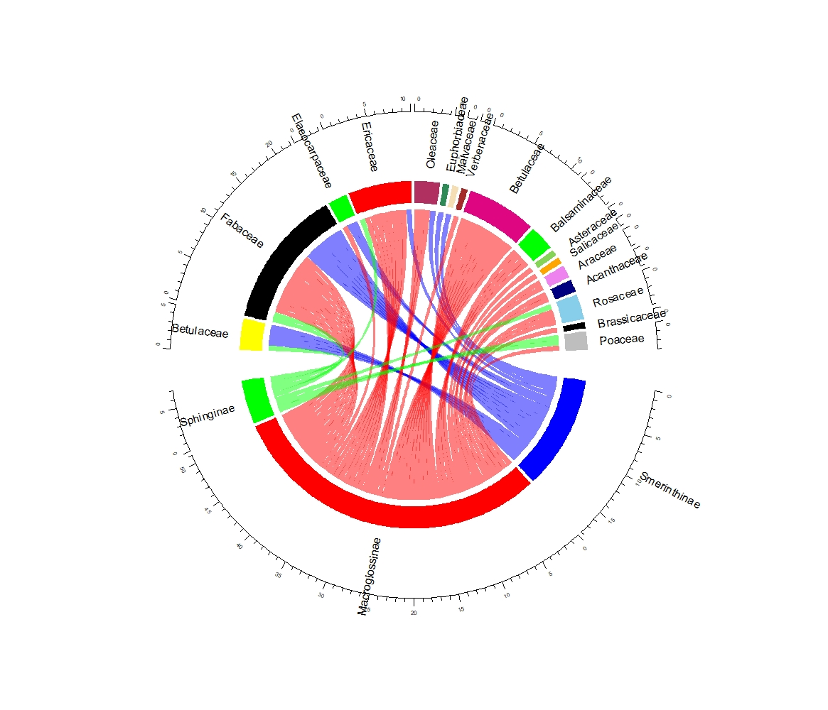**Figure 2.** Chord diagram showing moth subfamilies interacting with plant families (based upon Table 2)

|  |
| --- |
|  |
|  |
|  |

## Altitudinal distribution of hawk moths and their pollen carrying capacity

We divided the survey areas into three zones, i.e., Zone A: 100–1000m (Tropical wet evergreen forest); Zone B: 1001–2000m (Sub-tropical montane forest) and Zone C: above 2000m (Temperate evergreen forest). Among three zones, diversity of Macroglossinae is more than Smerinthinae and Sphinginae (Figure 3).

**Figure 3.** Altitudinal distribution of Sphingidae moth species

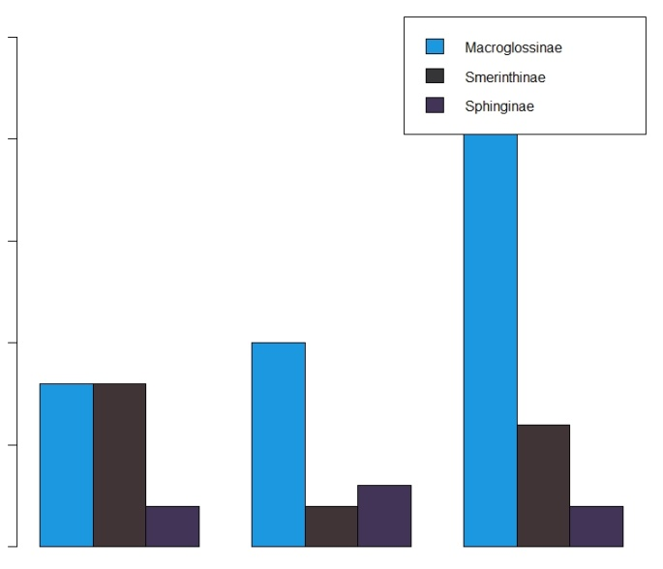

Tropical wet evergreen Sub-Tropical Montane Temperate evergreen

To check the similarity between diversity of three subfamilies at three altitudinal zones was analyzed by Jaccard’s similarity index. Similarity between Zone A and Zone B is found to be 10.52%; Zone B and Zone C is 22.72%; Zone A and C is 16.66%. Zone B (1001–2000m) and Zone C (above 2000m) are more similar than Zone A (100–1000m). That means maximum potential pollinator hawk moths are distributed in higher altitudes(Table 3).

|  |  |  |  |
| --- | --- | --- | --- |
| Altitudinal zones | 100-1000 | 1001-2000 | above 2000 |
| 100–1000 | 1 | 0.105263 | 0.166667 |
| 1001–2000 | 0.105263 | 1 | 0.227273 |
| above 2000 | 0.166667 | 0.227273 | 1 |

**Table 3.** Similarity index

**With altitudinal distribution, pollen carrying capacity among Macroglossinae, Smerinthinae and Sphinginae varies significantly (Figure 4). It can be clearly seen that subfamily Macroglossinae carried a diverse range of pollen (2 > 250 pollen/proboscis) than other two subfamilies (Table 2; Figure 4).**

**Figure 4.** Pollen carrying capacity of Sphingidae moth subfamilies

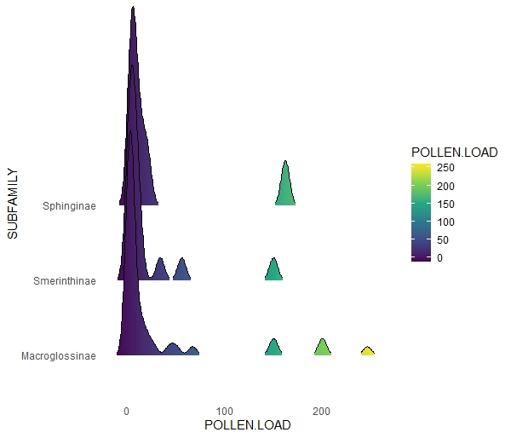

A box plot was made to show carrying capacity of pollen load of different plant taxa i.e., Betulaceae, Fabaceae, Ericaceae, Balsaminaceae, Rosaceae, Oleaceae, Poaceae, Elaeocarpaceae by three Sphingidae subfamilies (Figure 5).

**Figure 5.** Box plot showing pollen load of major plant taxa among three sub families

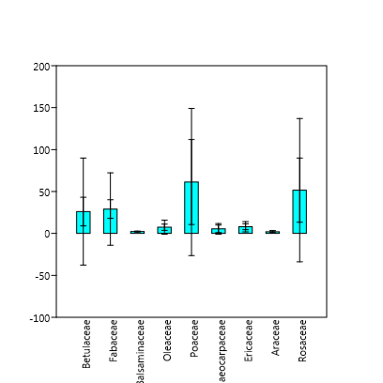

On the basis of box plot data and ridge plot data, we have chosen the Macroglossinae subfamily for one-way ANOVA analysis. Because among three subfamilies, species of Macroglossinae have diverse range of pollen carrying capacity, on the other context high pollen abundancy of various plant taxa is related in majority with Macroglossinae. Our null hypothesis was that no other factor is responsible for pollen carrying capacity other than pollen structure among different species of Macroglossinae. We got the *p* value 0.3942 which is not significant (F=1.227, df=7.566, p=0.3942). Thus, our null hypotheses got rejected and it can be suggested that there are other factors that may induce the pollen carrying capacity like altitude, season etc.

## Pollen abundancy and pollen frequency

Pollen abundancy and pollen frequency are the two most important parameters to study the interaction of plant taxa and moth species. We have used pollen spectra to study these parameters.

Pollen abundancy means, pollens of a particular plant taxon are carried by how many individuals of moths (%). Abundancy of different taxon is Fabaceae (32.84%), Betulaceae (22.39 %), Ericaceae (14.93%), Balsaminaceae, Oleaceae and Rosaceae (5.97%), Poaceae and Elaeocarpaceae (4.48%), Araceae (2.99%) and Euphorbiaceae, Malvaceae, Acanthaceae, Brassicaceae, Salicaceae, Verbenaceae and Asteraceae (1.49%). It also reveals that among 8 genuses of subfamily Macroglossinae, representatives of *Theretra* carry pollen grains of 6 plant families viz. Betulaceae, Fabaceae, Balsaminaceae, Salicaceae, Oleaceae, Elaeocarpaceae, Rosaceae, Acanthaceae followed by *Rhagastis* (7 representatives, 6 plant families) ; *Acosmeryx* (9 representatives, 5 plant families); *Cechetra* (9 representatives, 4 plant families); *Daphnis* (4 representatives, 4 plant families); *Macroglossum* (1 representatives, 1 plant families); Eupanacra (1 representatives, 1 plant families); *Ampelophaga* (1 representatives, 1 plant families). Under Smerinthinae, 11 representatives of genus Ambulyx carry pollen of 5 plant families and 2 representatives of *Marumba* carry pollen grains of 2 plant families and one representative of *Clanis* carry pollen grains of 1 plant families. Among 4 genuses of Sphinginae, 5 representatives of *Psilogramma* carry pollen grains of 4 plant families and single representative of *Dolbina, Pergesa* and *Acherontia* carry pollen grains of single plant family (Supplementary data: S2, Fig. 6)

Pollen frequency is percentage of how many pollen grains of a particular plant taxon are present on a single proboscis in a single view of light microscope. It is observed that Betulaceae, Fabaceae, Oleaceae, Elaeocarpaceae, Ericaceae, Balsaminaceae, Araceae, Rosaceae show frequency of (10–100%). Though abundancy is very low, Salicaceae, Brassicaceae, Euphorbiaceae, Malvaceae, Acanthaceae and Poaceae show 100% frequency.

**Figure 6.** Pollen spectra showing pollen abundancy and pollen frequency of plant taxa

***Ambulyx*=blue, *Cechetra*=red, Theretra=green, *Rhagastis*=brown, *Daphnis*=violet, *Psilogramma*=yellow, *Acosmeryx*=black, *Marumba*=orange, rest of all= grey**

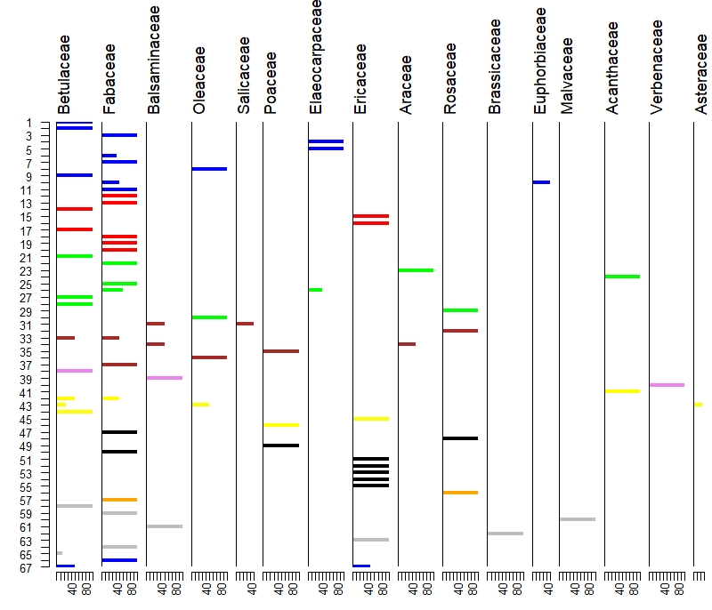

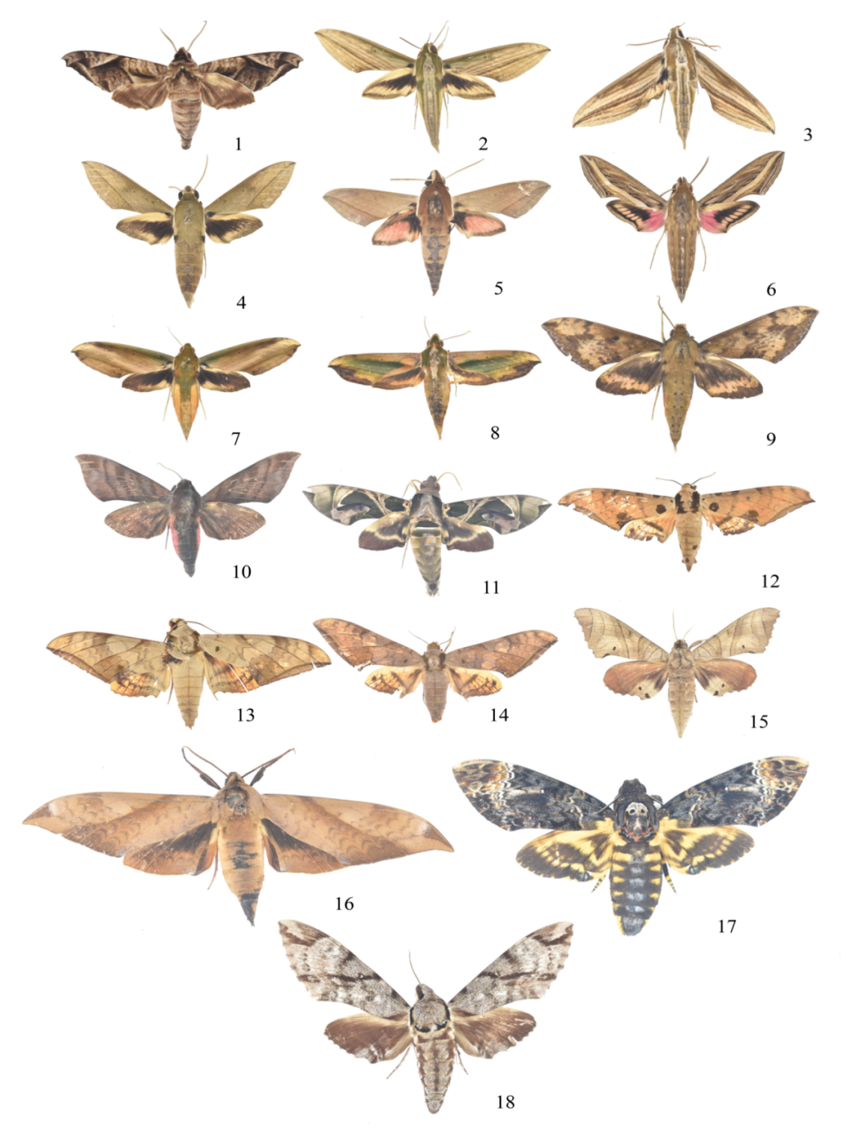**Figure 7.** Pollens of different plant family

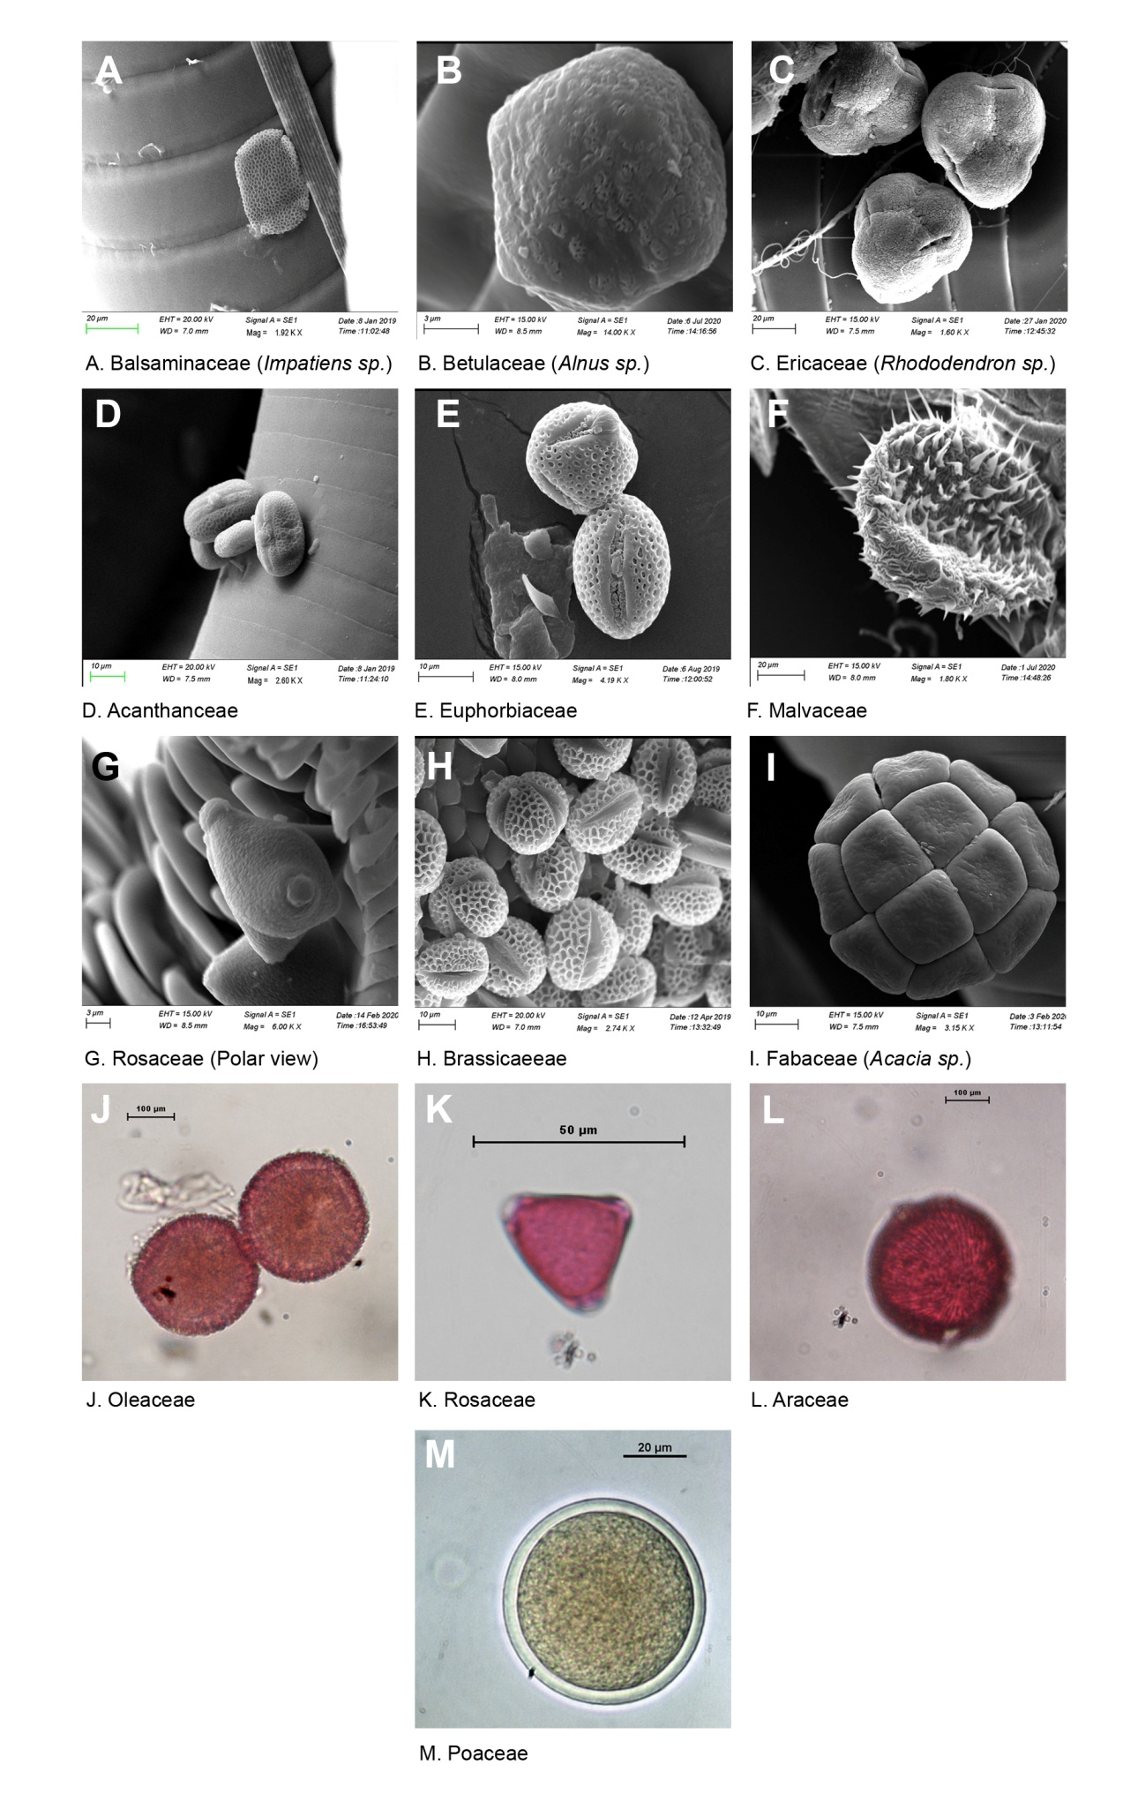

**Figure 8.** Potential Sphingidae moth pollinators carrying 5 or more than 5 pollen grains/ proboscis

**A. Macroglossinae:** 1. *Acosmeryx naga*; 2. *Cechetra minor*; 3. *Cechetra minor*; 4. *Theretra clotho*; 5. *Theretra alecto*, 6. *Theretra oldenlandiae*, 7. *Theretra nessus*, 8. *Pergesa acteus*, 9. *Rhagastis lunata*, 10. *Ampelophaga khasiana*, 11. *Daphnis hypothous*; **B. Smerinthinae:** 12. *Ambulyx ochracea*, 13. *Ambulyx substrigilis*, 14. *Ambulyx liturata*, 15. *Marumba sperchius*, 16. *Clanis deucalion*; **C. Sphinginae:** 17. *Acherontia lachesis*; 18. *Psilogramma renneri*

# Discussion

**Relationship between moth and pollen assemblage in relation to the vegetation**

The study reveals that the moths have a close relationship with the existing vegetation of the study areas and serve as indicator of the current vegetation scenario and climate in the region. The overall pollen study on the pollen adherence on the moth proboscis reveals that, the surrounding areas is indicative of the subtropical evergreen forest mixture of broad-leaved taxa composed of *Betula*, Oleaceae, *Quercus*, *Elaeocarpus*, Fabaceae and *Rhododendron* under warm and humid condition in the region. The continuous recovery of cereal, *Brassica* and Solanaceae pollen are indicative of the anthropogenic activity in the region. The presence of *Impatiens* pollen was marked in the moth samples and strongly indicative of the high rainfall activity in the region. We have performed the scanning electron microscope observation of the proboscis of the collected major moth samples---- and confirmed that moth may carry a laden of pollen grains of the particular pollen in relation to the pollination types. However, in some moth samples it was observed that there are different types of pollen observed which indicative of the moths can visit and consume nectar from numbers of flowers in relation to the different habitats.

**Moths and Pollen diversity**

The study on hawk moth proboscis reveals that, the pollen taxa especially Oleaceae, Malvaceae and Balsaminaceae are regularly observed, which is good agreement with earlier records (Johnson & Raguso, 2016; O et al. 2011; Ryckewaert et al. 2011). However, it is also observed that, the diversity of the pollen was high in the Macroglossinae family in comparison to the Smerinthinae and Sphinginae family which displayed a good agreement to the distribution of the Hawk moths in the region. It is confirmed that the moths of Macroglossinae family are performed as a good pollinator and can be migrated up to several kilometers as evidenced by the presence of *Rhododendron*, *Quercus*, and Rosaceae in the moth proboscis.

**Palynoassemblages and environmental indicators**

Arunachal Pradesh, Sikkim comprise of various medicinally and economically plant taxa i.e. Solanaceae, Bignoniaceae, Urticaceae, Primulaceae, Anacardiaceae, Rananculaceae(Mao et al., 2009). In North-Bengal important plant taxa like Malvaceae, Amaranthaceae, Asteraceae, Araceae, Acanthaceae, Scrophulariaceae, Verbenaceae, Fabaceae, Zingiberaceae, Solanaceae, Caryophyllaceae, Boraginaceae, Euphorbiaceae, Lamiaceae and Plumbaginaceae are mainly predominant. (Das, 2021).

Palynological data of 14 taxa have been identified with 65 hawk moth species who strongly suggest evidence towards Sphingophily. Pollen spectra helps in understanding the Presence of pollens of shrubs, herbs and trees in proboscises of hawk moths is significant to construct palynoassemblages and polyphagy nature of sphingidae. Recovery of shrubby taxa Rhododendron (Ericaceae), Euphorbiaceae, Balsaminaceae in the paleoassemblages is strong supportive evidence of monsoonal activity in this region (Basumatarey et al, 2019). Besides seasonal indicator Rhododendron also elucidate migratory behaviors of hawk moths between a long elevational distance as these taxa grows only in higher Himalaya. Presence of Salicaceae, in this assemblage is the indication of presence moist environmental condition. Regular presence of taxa such as Fabaceae, Betulaceae, mainly indicates high preferences of moths for collection pollens. Species of these subfamilies shows variations in carrying capacity of pollen load seasonally (Pre-monsoon, Monsoon, and Post-monsoon).

**Interaction of subfamilies with plant taxa**

In Africa, some major sphinx genuses i.e., *Agrius, Hippotion, Basiothia, Nephele, Macroglossum, Temnora, Hyles* interacts with various plant taxa. Orchids show most interactions with hawk moths. Orchidaceae, another African grassland orchid *Havenaria clavata*(Johnson et al., 2020; Steen et al., 2019)*,* endangered western prairie fringed orchids *Platanthera praeclara* with *Sphinx drupiferarum* and *Hyles gallii* besides interaction with medium, large and small sized inflorescences (Borkowsky & Westwood, 2009) , *Habenaria limprichtti* in China(Tao et al., 2018).Eastern Himalaya forests of Arunachal Pradesh are rich in terms of floristic compositions. A total of 482 plant species were recorded. Maximum species of angiosperms are distributed among Fabaceae, Asteraceae, Ericaceae, and Euphorbiaceae(Saikia et al., 2017).In Central Himalaya Sikkim the flowering plants are represented by about 4458 species in the state. Main taxa are Orchidaceae, Rosaceae, Asteraceae, Rubiaceae, Fabaceae, and Betulaceae (Flowering plants of Sikkim- an analysis, Sing and Sanjappa).

Chord diagram analysis quantitatively elucidates how three subfamilies interact with different plant taxon. Macroglossinae shows interaction in highest number with plant taxa i.e., Fabaceae, Ericaceae, Oleaceae, Asteraceae, Acanthaceae, Balsaminaceae, Salicaceae, Rosaceae, Brassicaceae, Fabaceae in terms of pollen carrying capacity. Higher diversity of Macroglossinae among 3 subfamilies in sub-tropical montane zone than other two forest types and distribution of potential pollinator hawk moths in higher altitudes represents a migratory behavior as Ericaceae, Balsaminaceae mainly distributed at more than 1200ft. Other two subfamilies i.e., Smerinthinae and Sphinginae show their interaction with monocot Poaceae, Betulaceae, Elaeocarpaceae, Malvaceae, Euphorbiaceae, Fabaceae (101.62 -2330 m) which represents a less impact in carrying capacity. Due its hovering nature more food supply is needed which may have impact on pollen attachment and participating in a crucial role related to pollination of these angiosperms. High pollen abundancy and frequency of plant taxa i.e., Fabaceae, Betulaceae, Ericaceae, Rosaceae and Balsaminaceae species and carrying of heavy pollen load of Fabaceae and Betulaceae by species of Macroglossinae subfamily indicates towards some advance characters than Smerinthinae and Sphinginae. Though data is insufficient but it is evident that hawks can interact with plant taxa in various altitudes.

Using of SEM and LM gives an illustrative concept on attachment of plant taxa on proboscis. Surface pattern of proboscis of Sphingidae is primitive than other settling moths. Irrespective of primitive characteristics hawks attach more pollen than settling moths. On basis of diversified interactions of species of Macroglossinae Welch F test shows average pollen load data and exine layer ornamentation shows signification variation in pollen attachment. Ornamentation with reticulate, echinate, verrucate has more affinity towards proboscis than regulate pattern. Two important component viscin thread and pollenkitt have high impact in this interaction. High pollen load of Ericaceae, Fabaceae, Brassicaceae through viscin thread with proboscis surface strongly suggest affinity of pollens for Sphingophily.(Pacini & Hesse, 2005).Carrying capacity of palynological material of more than one plant taxa strongly suggests polyphagic nature. Medicinal values of species under genus *Rhododendron* (Ericaceae) and *Impatiens* (Balsaminaceae) are well known. In North-East India a total of 80 and 83 species are found of these respective genuses. We have found 8 interactions of *Rhododendron* and 6 of *Impatiens. Acosmeryx naga* and *Cechetra bryki* are seems to be good pollinators for *Rhododendron*. Among 29 hawk moth species, 18 species are seemed as potential pollinators on the basis of carrying 5 or more than 5 pollen grains. Based on the previous literature and our study it has been observed that species under *Acosmeryx, Cechetra, Pergesa, Ampelophaga, Daphnis, Clanis, Acherontia, Psilogramma* show unique interactions with plant taxa. From this altitude wise interaction study can indicate some other biochemical, physical parameters related to moth pollination in future studies.

# Conclusions

This palynological study may have taken an important role to display the relation between modern pollen and vegetation relationship, migration of moths and current land use form in the region. This study will also be very helpful for the understanding the pollination biology in relation to the moth species in the region.

**Future aspect**

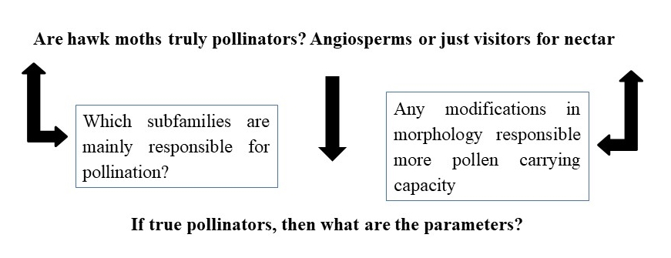

# References

Alexandersson, R., & Johnson, S. D. (2002). Pollinator–mediated selection on flower–tube length in a hawkmoth–pollinated Gladiolus (Iridaceae). *Proceedings of the Royal Society of London. Series B: Biological Sciences*, *269*(1491), 631–636. https://doi.org/10.1098/rspb.2001.1928

Atwater, M., & Lott, T. (2011). A Simple Technique to Sample Pollen From Moths and Its Applications to Ecological Studies. *Journal of the Lepidopterists’ Society*, *65*, 265–267. https://doi.org/10.18473/lepi.v65i4.a8

Banza, P., Belo, A., & Evans, D. (2015). The structure and robustness of nocturnal Lepidopteran pollen-transfer networks in a Biodiversity Hotspot. *Insect Conservation and Diversity*, *8*. https://doi.org/10.1111/icad.12134

Borkowsky, C., & Westwood, A. (2009). *Seed capsule production in the endangered western prairie fringed orchid (Platanthera praeclara) in relation to sphinx moth (Lepidoptera: Sphingidae) activity.* Undefined. /paper/Seed-capsule-production-in-the-endangered-western-Borkowsky-Westwood/8f6ff5a82ae82788f238dfcf11498d2f9fc304ad

Chakravarty, S., Suresh, C. P., Puri, A., & Shukla, G. (2012). *North-east India, the Geographical Gateway of India’s Phytodiversity*. Undefined. /paper/North-east-India%2C-the-Geographical-Gateway-of-Chakravarty-Suresh/48eb275ceba62a5bbfcc93de64ba7f229d48c001

Chandra, K., Gupta, D., Gopi, K. C., Tripathy, B., & Kumar, V. (2018). *Faunal Diversity of Indian Himalaya*.

Das, A. P. (n.d.). Medicinal Plants: Suitable for growing in Northern Bengal. *University of North Bengal*. Retrieved February 3, 2021, from https://www.academia.edu/38606395/Medicinal_Plants_Suitable_for_growing_in_Northern_Bengal

de Camargo, A. J. A., de Camargo, N. F., Corrêa, D. C. V., de Camargo, W. R. F., Vieira, E. M., Marini-Filho, O., & Amorim, F. W. (2016). Diversity patterns and chronobiology of hawkmoths (Lepidoptera, Sphingidae) in the Brazilian Amazon rainforest. *Journal of Insect Conservation*, *20*(4), 629–641. https://doi.org/10.1007/s10841-016-9894-6

Fox, K., Vitt, P., Anderson, K., Fauske, G., Travers, S., Vik, D., & Harris, M. O. (2013). Pollination of a threatened orchid by an introduced hawk moth species in the tallgrass prairie of North America. *Biological Conservation*, *167*, 316–324. https://doi.org/10.1016/j.biocon.2013.08.026

Grant, V. (1983). The Systematic and Geographical Distribution of Hawkmoth Flowers in the Temperate North American Flora. *Botanical Gazette*, *144*(3), 439–449. https://doi.org/10.1086/337395

Haber, W. A., & Frankie, G. W. (1989). A Tropical Hawkmoth Community: Costa Rican Dry Forest Sphingidae. *Biotropica*, *21*(2), 155–172. https://doi.org/10.2307/2388706

Hahn, M., & Brühl, C. A. (2016). The secret pollinators: An overview of moth pollination with a focus on Europe and North America. *Arthropod-Plant Interactions*, *10*(1), 21–28. https://doi.org/10.1007/s11829-016-9414-3

Hammer, O., Harper, D., & Ryan, P. (2001). PAST: Paleontological Statistics Software Package for Education and Data Analysis. *Palaeontologia Electronica*, *4*, 1–9.

Johnson, S. D., Balducci, M. G., & Shuttleworth, A. (2020). Hawkmoth pollination of the orchid Habenaria clavata: Mechanical wing guides, floral scent and electroantennography. *Biological Journal of the Linnean Society*, *129*(1), 213–226. https://doi.org/10.1093/biolinnean/blz165

Johnson, S. D., & Raguso, R. A. (2016). The long-tongued hawkmoth pollinator niche for native and invasive plants in Africa. *Annals of Botany*, *117*(1), 25–36. https://doi.org/10.1093/aob/mcv137

Kritsky, G. (1991). Darwin’s Madagascan Hawk Moth Prediction. *American Entomologist*, *37*(4), 206–210. https://doi.org/10.1093/ae/37.4.206

Macgregor, C. J., Pocock, M. J. O., Fox, R., & Evans, D. M. (2015). Pollination by nocturnal Lepidoptera, and the effects of light pollution: A review. *Ecological Entomology*, *40*(3), 187–198. https://doi.org/10.1111/een.12174

Mao, A. A., Hynniewta, T. M., & Sanjappa, M. (2009). Plant wealth of Northeast India with reference to ethnobotany. *IJTK Vol.8(1) [January 2009]*. http://nopr.niscair.res.in/handle/123456789/2979

Martins, D. J., & Johnson, S. D. (2013). Interactions between hawkmoths and flowering plants in East Africa: Polyphagy and evolutionary specialization in an ecological context. *Biological Journal of the Linnean Society*, *110*(1), 199–213. https://doi.org/10.1111/bij.12107

O, C.-N., Ic, M., Ja, D., & Av, L. (2011). Synchronous phenology of hawkmoths (Sphingidae) and Inga species (Fabaceae-Mimosoideae): Implications for the restoration of the Atlantic forest of northeastern Brazil. *Biodiversity and Conservation*, *20*(4), 751–765. https://doi.org/10.1007/s10531-010-9975-x

Pacini, E., & Hesse, M. (2005). Pollenkitt – its composition, forms and functions. *Flora - Morphology, Distribution, Functional Ecology of Plants*, *200*(5), 399–415. https://doi.org/10.1016/j.flora.2005.02.006

Paudel, B. R., Kessler, A., Shrestha, M., Zhao, J. L., & Li, Q.-J. (2019). Geographic isolation, pollination syndromes, and pollinator generalization in Himalayan Roscoea spp. (Zingiberaceae). *Ecosphere*, *10*(11), e02943. https://doi.org/10.1002/ecs2.2943

*R: The R Project for Statistical Computing*. (n.d.). Retrieved October 4, 2021, from https://www.r-project.org/

Rana, S. K., & Rawat, G. S. (2017). Database of Himalayan Plants Based on Published Floras during a Century. *Data*, *2*(4), 36. https://doi.org/10.3390/data2040036

Ryckewaert, P., Razanamaro, O., Rasoamanana, E., Rakotoarimihaja, T., Ramavovololona, P., & Danthu, P. (2011). Sphingidae as likely pollinators of Madagascar’s baobabs. *Bois et Forets Des Tropiques*, *65*, 55–68.

Saikia, P., Deka, J., Bharali, S., Kumar, A., Tripathi, O. P., Singha, L. B., Dayanandan, S., & Khan, M. L. (2017). Plant diversity patterns and conservation status of eastern Himalayan forests in Arunachal Pradesh, Northeast India. *Forest Ecosystems*, *4*(1), 28. https://doi.org/10.1186/s40663-017-0117-8

Sheviak, C. J., & Bowles, M. L. (1986). THE PRAIRIE FRINGED ORCHIDS: A POLLINATOR—ISOLATED SPECIES PAIR. *Rhodora*, *88*(854), 267–290.

Steen, R., Norli, H. R., & Thöming, G. (2019). Volatiles composition and timing of emissions in a moth-pollinated orchid in relation to hawkmoth (Lepidoptera: Sphingidae) activity. *Arthropod-Plant Interactions*, *13*(4), 581–592. https://doi.org/10.1007/s11829-019-09682-3

Sublett, C. A., Cook, J. L., & Janovec, J. P. (2019). Species richness and community composition of sphingid moths (Lepidoptera: Sphingidae) along an elevational gradient in southeast Peru. *Zoologia*, *36*, 1–11. https://doi.org/10.3897/zoologia.36.e32938

Tao, Z.-B., Ren, Z.-X., Bernhardt, P., Wang, W.-J., Liang, H., Li, H.-D., & Wang, H. (2018). Nocturnal hawkmoth and noctuid moth pollination of Habenaria limprichtii (Orchidaceae) in sub-alpine meadows of the Yulong Snow Mountain (Yunnan, China). *Botanical Journal of the Linnean Society*, *187*(3), 483–498. https://doi.org/10.1093/botlinnean/boy023

Tuttle, J. P. (2007). *The Hawk Moths of North America: A Natural History Study of the Sphingidae of the United States and Canada*. Undefined. /paper/The-Hawk-Moths-of-North-America%3A-A-Natural-History-Tuttle/0e492d03a2524c03b7d03f34d33777590d80c481

Walton, R. E., Sayer, C. D., Bennion, H., & Axmacher, J. C. (2020). Nocturnal pollinators strongly contribute to pollen transport of wild flowers in an agricultural landscape. *Biology Letters*, *16*(5), 20190877. https://doi.org/10.1098/rsbl.2019.0877

Walton, R., Sayer, C., Bennion, H., & Axmacher, J. (2021). Improving the pollinator pantry: Restoration and management of open farmland ponds enhances the complexity of plant-pollinator networks. *Agriculture Ecosystems & Environment*, *320*, 107611. https://doi.org/10.1016/j.agee.2021.107611

Willmott, A. P., & Búrquez, A. (1996). The pollination of merremia palmeri (Convolvulaceae): Can hawk moths be trusted? *American Journal of Botany*, *83*(8), 1050–1056. https://doi.org/10.1002/j.1537-2197.1996.tb12802.x

Young, B. E., Auer, S., Ormes, M., Rapacciuolo, G., Schweitzer, D., & Sears, N. (2017). Are pollinating hawk moths declining in the Northeastern United States? An analysis of collection records. *PLOS ONE*, *12*(10), e0185683. https://doi.org/10.1371/journal.pone.0185683

Basumatary Sk., Narzary D and Brahma M. 2017. A comparative palynological study on butterfly mud puddling localities and surface forest samples: a case study from northeast India. Palynology, 41(1(: 132-143.

Gupta HP and Sharma C. 1986. Pollen flora of North-west Himalaya. Indian Association of Palynostratigraphers, Lucknow, India.

Nayar TS. 1990. Pollen flora of Maharashtra State, India. Today and Tomorrow’s Printers & Publishers, New Delhi, India.